Batch: B2 Roll No.: 16010121200

Experiment / assignment / tutorial No. 9

Grade: AA / AB / BB / BC / CC / CD /DD

Signature of the Staff In-charge with date

Experiment No.: 9

TITLE: Study and configure DHCP & DNS protocol using Cisco Packet tracer

AIM: To study and configure DHCP/DNS protocol using Cisco Packet tracer
_____________________________________________________________________________
Expected Outcome of Experiment:
CO:
_____________________________________________________________________________
Books/ Journals/ Websites referred:
- A. S. Tanenbaum, “Computer Networks”, Pearson Education, Fourth Edition
- B. A. Forouzan, “Data Communications and Networking”, TMH, Fourth Edition
_____________________________________________________________________________
Pre Lab/ Prior Concepts:
IPv4 Addressing, Subnetting, Link State Protocol, Router configuration Commands
_____________________________________________________________________________
New Concepts to be learned: DHCP/DNS Protocol and its configuration.
_____________________________________________________________________________
THEORY:
Domain Name System (DNS) is an Internet service that translates domain names (e.g., its.umich.edu) into IP addresses.
Dynamic Host Configuration Protocol (DHCP) is a protocol for automatically assigning IP addresses and other configurations to devices when they connect to a network.

IMPLEMENTATION:
Network:
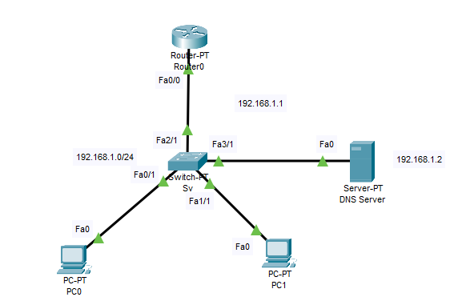

Router Configuration:
1. Assign IP Address to the FastEthernet 0/0 interface:
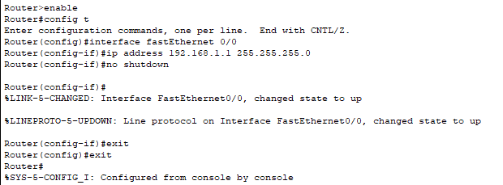

2. Create DHCP Pool and configure network and default gateway:
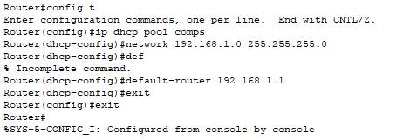

3. Select DHCP in IP configuration of PCs
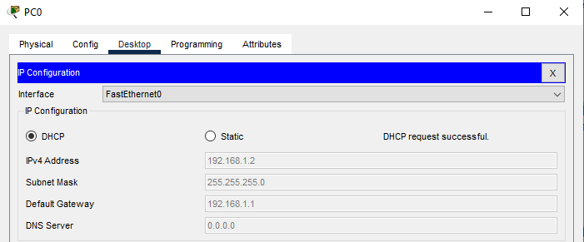
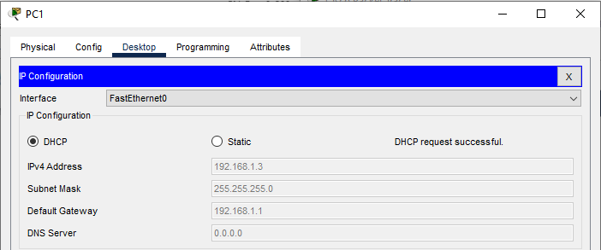

4. Add DNS Server to the network and assign IP address to the server. First remove DHCP IP configurations from both PCs.

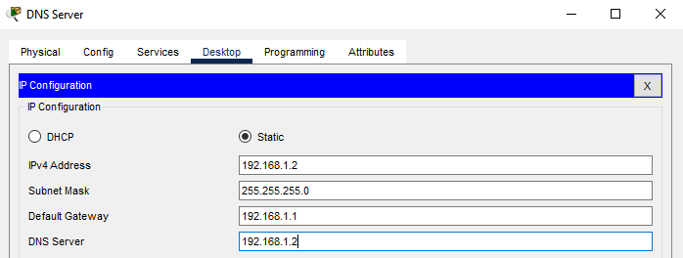

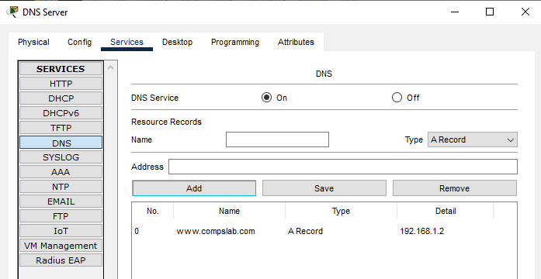

5. Configure DNS Server and excluded addresses from the pool of IP addresses on router
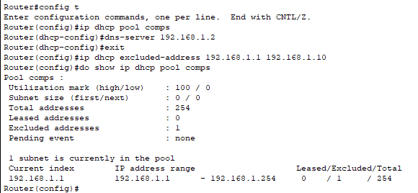

6. Updated IP Configurations of PC0 and PC1 after configuring DNS server and excluded addresses
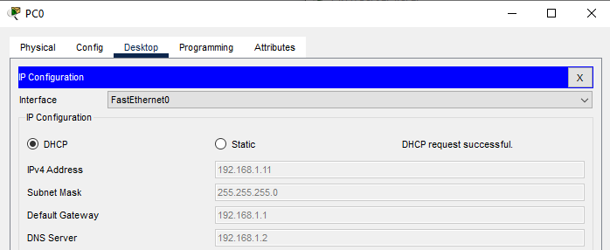
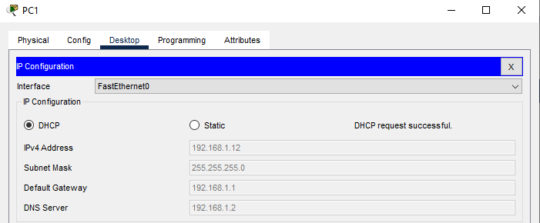

7. www.compslab.com entered in address bar of Web Browser of PC0
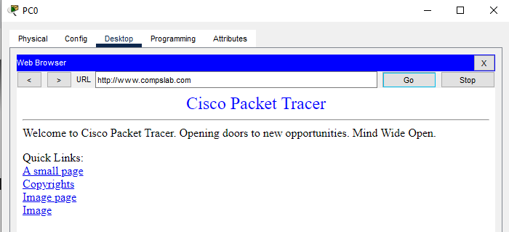

CONCLUSION:
Studied and configured DHCP/DNS protocol using Cisco Packet Tracer.

Date: 16/10/2023 Signature of faculty in-charge

